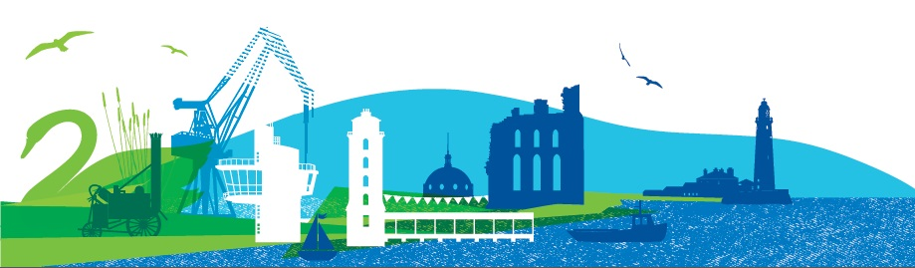
Issue 9
July 2021

Patient Forum Bulletin
For Practice Patient Groups in North Tyneside
Welcome to the latest edition of the Patient Forum Bulletin in which we update GP Practice Patient Groups about what’s happening in the Forum. The COVID-19 Pandemic continues to impact on us and the way we work and we continue to meet by video using Microsoft Teams for both Forum meetings and for our working groups too. This will continue until deemed safe to resume face to face meetings.
Patient Forum meeting 22nd July 2021
The Patient Forum met on 22^{ne} July using Microsoft Teams and were joined by Dr Lesley Young Murphy and Marc Rice from the CCG, Claire Howard VCS Health Coordinator and Kate Byrnes from Northumbria University.
Working Groups Information
The Working Group briefing accompanies this Bulletin summarising the most recent meetings of each group.
The Forum were asked to give some thought to how conversations regarding frailty could be initiated with patients in a sensitive and non-confrontational way and their feedback will be used to help drive best practice.
Work is continuing to formulate a plan to widen the scope of patient engagement throughout the whole community to ensure all groups are represented and this will be published soon.
CCG update
Dr Lesley Young-Murphy Executive Director of Nursing and Chief Operating Officer
NHS North Tyneside CCG gave an update.

The Health and Care Bill is progressing through Parliament and is still on target for the establishment of an Integrated Care System by 1st April 2022. All parties involved are working towards the transition and to ensure that staff are given the necessary support and guidance and to ensuring a continued commitment to both long and short term plans for healthcare in the region.

Following the relaxation of COVID-19 guidelines, all NHS buildings will continue to require the wearing of face masks, hand washing/sanitisation and social distancing.
Read more here:
www.northtynesideccg.nhs.uk/a-plea-from-gp-practices-across-north-tyneside
There has been a good uptake of the vaccine in North Tyneside and the service is now being provided by Community Pharmacies.

LIVI the online GP consultation service currently being piloted is being evaluated at present, this evaluation should be completed by the end of July and the results published.

Marc Rice shared the CCG Annual report 2020/21 and we were given a preview of a video which is in production. This will be on the CCG website once finalised.
For more information go to:
www.northtynesideccg.nhs.uk/annual-report-2020-21/

Marc updated us on work ongoing with GP websites, four practices have agreed to be involved in a pilot to update GP Practice websites and make them more user friendly with better connection to local services. The Forum will also be involved through the Innovations Working Group.
Claire Howard updated us on progress with the Living Well North Tyneside website which has been in the planning stages for the last 18 months. Provider organisations have started to upload their information and the next stage will be testing. Members of the Forum will be invited to take part in the testing. It was also confirmed that they are looking at non-digital methods of accessing information for those without internet access.

Kate Byrnes – Northumbria University
Care Homes research update
We received a recap of the work streams involved in the Care Home research project.
Both work streams are progressing with interviews being conducted with Care Home staff and management. The project presented to the British Society of Gerontology Annual Conference in July and this was very well received.
Keep up to date with progress by visiting the website; https://research.northumbria.ac.uk/SafeST
Useful Links
www.northtynesideccg.nhs.uk/
www.healthwatchnorthtyneside.co.uk
www.ageuk.org.uk/northtyneside
www.voda.org.uk
www.nhs.uk/coronavirus
www.gov.uk/coronavirus
my.northtyneside.gov.uk/category/1429/coronavirus-covid-19

