Issue 2
December 2022
North Tyneside Patient Forum Newsletter
In this Issue
Cost of living support
Covid-19 update
Enhanced access
Christmas Pharmacy and GP practice opening times
STI Home testing kit
Healthier together
Can you identify this?
Alcohol Awareness
Death Café
North Tyneside Carers Centre
Health Inequalities Grant
Member profile
Patient Forum Highlights
Did You identify?

Welcome to the latest issue and Season’s Greetings from the members.

Keep up to date with latest local news
Twitter: @NHSNorthTyne
Facebook: NHS North Tyneside
Website: https://nenc-northtyneside.icb.nhs.uk/
YouTube: https://www.youtube.com/channel/UCBrlByVBprLY3x9ob3ct2nw/videos

Cost of living support
The rising cost of living, through increasing energy, food and fuel costs, is affecting many of us.

North Tyneside Council is committed to supporting residents, especially those most affected, and businesses. On this link, you will find the support available from the Council, advice, and signposting to other relevant organisations. This includes help for families and individuals, whether you’re working or not.

The rising cost of living, and the support to help to deal with it, is changing quickly. North Tyneside Council will regularly review and update these pages to reflect that.
https://my.northtyneside.gov.uk/category/1652/cost-living-support

Coronavirus (COVID-19)
For NHS information: https://www.nhs.uk/conditions/coronavirus-covid-19/
For Government guidelines:
https://www.gov.uk/coronavirus
For local information: https://my.northtyneside.gov.uk/category/1429/coronavirus-covid-19

Enhanced Access:Evening and weekend appointments

From 1st October 2022 all four North Tyneside Primary Care Networks (PCNs) will offer additional evening and weekend appointments either at practices or at an NHS service nearby, including The Oxford Centre, North Shields Health Hub and The Battle Hill Health Centre. The appointments will be available to support a growing number of services for example, general consultations (Nurse and GP), vaccinations, health checks and screening, to name a few. Appointments will also continue to be made available on Sundays and Bank Holidays at the Battle Hill Health Centre.
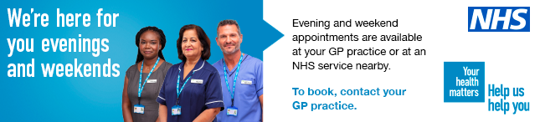
Patients are advised to speak to their GP reception team to book or visit their GP practice website for more details.

Additional information can be found on the Tynehealth website https://tynehealth.org.uk

Christmas Pharmacy and GP practice opening times
Over the festive period your health is still considered important and a number of arrangements will be in place to ensure you can seek the advice you may need.

Extended access is only operating out of the Battle Hill Health Centre for the bank holidays this year with the following dates and times:

- Christmas Day 25 December 9.00am-1.00pm
- Boxing Day 26 December 11.00am-3.00pm
- Substitute Christmas Day 27 December 11.00am-3.00pm
- New Years Day 1 January 11.00am-3.00pm
- Substitute New Year’s Day 11.00am-3.00pm
All other non-bank holidays around Christmas are operating as usual at all hub locations.
North Tyneside pharmacy opening hours can be found on this link:
https://nenc-northtyneside.icb.nhs.uk/festive-pharmacy-opening-hours/

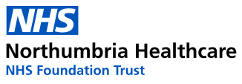
STI Home testing kit
If you are aged 18 or over and live in Northumberland or North Tyneside you can request a free sexually transmitted infection (STI) home testing kit.
A sexually transmitted infection (STI), is a bacterial or viral infection that can be passed on through unprotected sexual contact. Some STIs have symptoms but sometimes you can have an STI with no symptoms and not even know you have it! Regular testing is recommended and to test every time you change sexual partners.
Home testing kits are quick and easy to do and can be delivered to your door in discreet packaging. They are only suitable if you do not have any symptoms of an STI.
If you do have symptoms please contact your local One to One Centre to book an appointment.
Shiremoor: 0191 297 0441
Blyth: 01670 515151

More information can be found on this link

https://www.northumbria.nhs.uk/our-services/sexual-health-services/sti-testing/sti-home-testing-kits-over-18s

Healthier together

This link takes you to North East and North Cumbria trusted NHS healthcare advice, everything from coughs to fevers in babies and children to mental health advice for young people. The site offers the best advice for parents, carers, young people and health professionals.

https://www.nenc-healthiertogether.nhs.uk

Can you identify this regional landmark?

Find the answer on page 8

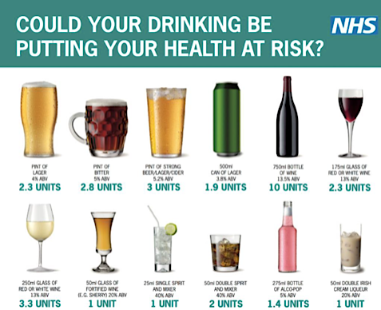
Alcohol awareness
https://www.nhs.uk/live-well/alcohol-advice/alcohol-support/
The idea of counting alcohol units was first introduced in the UK in 1987 to help people keep track of their drinking. Units are a simple way of expressing the quantity of pure alcohol in a drink. One unit equals 10ml or 8g of pure alcohol, which is around the amount of alcohol the average adult can process in an hour.
Men and women are advised not to drink more than 14 units a week on a regular basis.

Death Cafe

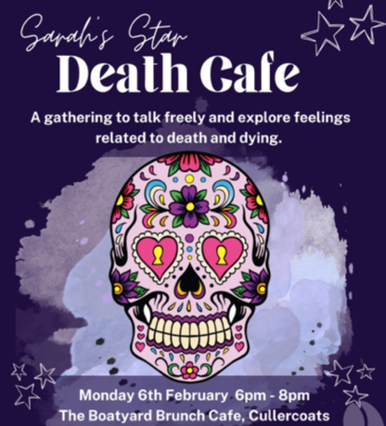
A death café is a place to talk about celebrating life, not worrying about death. We want to help people recognise that life is a part of living and instead of focusing on sadness, celebrating the life we get to live before we die.

Voicing our thoughts and fears surrounding death can help create a better understanding of it.

There is no pressure to share – you can just come along to listen.

Death cafes can be a very uplifting experience.

Contact Sarah’s Star at: www.facebook.com/SarahsStarOnline
Tickets are available from: www.bit.ly/DeathCafeNE

North Tyneside Carers Centre
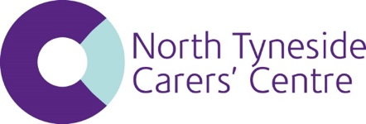
North Tyneside Unpaid Carer Support Groups
Spring 2023
With the new year just ahead of us, it is a good time to consider what we can do make our lives as unpaid carers a little bit less stressed and more connected.

North Tyneside Carers’ Centre runs groups to support carers like you. It’s an opportunity to relax and take a break from caring and meet with people who are in the same boat as you. Groups offer information about coping as a carer and the condition of the person you care for. The lived experiences from fellow carers can make all the difference in your caring role.
Here are the groups, if you would like to attend a group contact us and we can give you the full details:

AUTISM CARERS’ GROUP When: Monthly evening group
Where: Saville Exchange, Suite 1, Howard Street, North Shields NE30 1SE

BEREAVED CARERS’ GROUP When: Monthly lunchtime group
Where: Whitley Bay Comrades Club, The Links NE26 1PS

DEMENTIA CARERS’ GROUP When: Monthly morning group
Where: White Swan Centre, Killingworth, NE12 6SS

All CARERS’ GROUPS When: Monthly afternoon group
Where: Saville Exchange, Suite 1, Howard Street, North Shields NE30 1SE

MENTAL HEALTH CARERS’ GROUP When: Monthly evening group
Where: Saville Exchange, Suite 1, Howard Street, North Shields NE30 1SE

To attend a group for the first time or for more information ring or email: Ring 0191 643 2298 / Email enquiries@ntcarers.co.uk

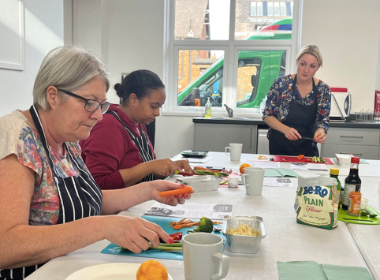
Health Inequalities Grant
Residents in North Tyneside have brushed up on their culinary skills by taking part in nutritionist led cooking sessions at the Linskill Centre.

From healthier Christmas Biscotti to 10-minute noodles, the free cooking classes teach participants tasty but nutritional recipes that can be replicated easily at home.

Each of the cooking courses are led by a qualified nutritionist and on average six participants attend the classes each week to learn new recipes, gain knowledge about ingredients and develop their cooking abilities.

Made possible by almost £30,000 funding from the Health Inequalities Fund which is hosted by VODA and funded by North Tyneside Council and the NHS North East and North Cumbria Integrated Care Board, the classes are part of the Linskill and North Tyneside Development Trusts commitment to helping its community improve its health.

Participants on the courses include parents and carers and dedicated classes run after school for children, young people and young carers.

With the cost-of-living impacting households across the borough, the courses also include meal planning on a budget, and teach parents how to make healthier meals for the whole family while still keeping costs as low as possible.
One of the popular courses is ‘Takeaway a Fakeaway’ where recipes have ranged from homemade, tasty Indian curries to Asian soy noodles. The aim is to encourage participants to opt to make their own healthier meals rather than order a takeaway.

Yossra has attended the Fakeaway course and reflecting on her experience she said: “I’ve learnt a lot on the course. I’ve learnt how to be patient and layer my flavours to make my food taste better and now I pay more attention to the ingredients I’m using and try and make my meals healthier where I can.”

Dorothy has also enjoyed the classes and thanks them for helping to build her confidence in the kitchen: “I cook and bake a lot more now and I’ve used everything I’ve learned at the classes to try my own recipes.

“It’s great to come along each week and learn new recipes, try new flavours and my husband loves that we’re making healthier stuff together. He asks to try all my new recipes!”

The Trust has also used the funding to increase the capacity of its allotment to grow more fruit and vegetables, meaning that young and old people have come together promote health, wellbeing and learning.

Anya Paradis, Director of Place (North Tyneside) NHS North East and North Cumbria Integrated Care Board, said "Eating a well-balanced diet is so important for your health. It provides you with the energy you need to keep active throughout the day, nutrients you need for growth and repair, helping you to stay strong and healthy and help prevent diet-related illness, such as some cancers. These cooking courses are helping people understand the link between what we eat and what our body needs to stay healthy. They set a strong foundation for not only participants, but also their family members in eating healthily for a longer and healthier life."

Cllr Karen Clark, Cabinet Member for Health and Wellbeing at North Tyneside Council, said: “Reducing health inequalities is really important to us and community organisations like the Linskill Trust are at the heart of our communities and make an invaluable contribution to working directly with our residents to tackle inequalities.

“Encouraging residents to make healthier choices is great, but to equip them with the skills, knowledge, and confidence to continue to make better choices and pass them onto their family is fantastic. Hearing first hand from participants how these cooking courses have translated into their everyday life is exactly what we aimed to achieve with the fund.”

The Health Inequalities Fund, developed by the members of the Better Together group, awarded grants of between £10,000 and £30,000 to fourteen Voluntary, Community and Social Enterprise (VCSE) sector organisations in Summer 2022.

All funded activities focus on delivering outcomes relating to the key themes of the recently published Equally Well strategy for North Tyneside – ‘Equal life chances for all’, ‘Thriving places and communities’ and ‘Maintaining independence’.

Thanks to Laura Bolden North Tyneside Council for this article.
Member Profile
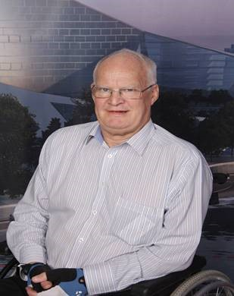
Patrick Mayne

I am 73 years old and worked in the UK for 30 years and South Africa for 16 years in the Pensions industry. I am skilled in a wide range of disciplines. These include Customer Service, Business Change Management, Human Resource, Project Management and IT Service Delivery. Qualified as an Actuary and Certified Director. My number one skill is electronic process engineer which is supported by customer service, risk management and corporate governance. As a process engineer it is key to simplify processes for the processor, maximise the customer value and ease of use whilst minimising risk. The human and digital interface is key.

I have considerable health experience since I had Polio at age of about 1 year old. Learning to walk, ankle operations, spinal problems, diabetic, arthritis, sleep apnoea and many other issues as well as two bouts of alcoholism and a period when I was suicidal. I have known meningitis, epilepsy, autism and many relatives died of cancer. As a result, I have always been interested in health services and spent many hours thinking of possible improvements. I have experience of the health service in the UK and South Africa.

Whilst I think our health service is one of the best in the world, I do think it can be improved considerably. Remove all the waste in the system, the current distribution of money to the front line is wasteful and ineffective. Social care staff must be brought up to the nursing pay levels and recognised as professionals. We must work towards making complete patient data available to all health professionals I am now in a wheel- chair in front of a laptop and looking to fill the next 15 years of my life which has been made possible by virtual meetings which have become more mainstream due to Covid. Hopefully COP28 will be virtual.

North Tyneside Patient Forum highlights
Clinical Commissioning Groups (CCGs) ceased to exist during the summer and Integrated Care Boards (ICBs) are now in place. Members of the Patient Forum took time to reflect on their impact and influence on health services in North Tyneside over many years.

The Patient Forum goes from strength to strength in the new arrangements and this video link demonstrates the vast amount of involvement members have had.
https://youtu.be/gnD0sMUr6Y0

Did you identify this?

Answer: Fenwick’s window

Thank you to Sam Stephenson for the image.

This newsletter has been produced quarterly by members of the North Tyneside Patient Forum Communications Working Group.

If you like the sound of the Patient Forum and would be interested in being part of it please contact; Michele Spencer michele@chcfnorthtyneside.org.uk for more information.

